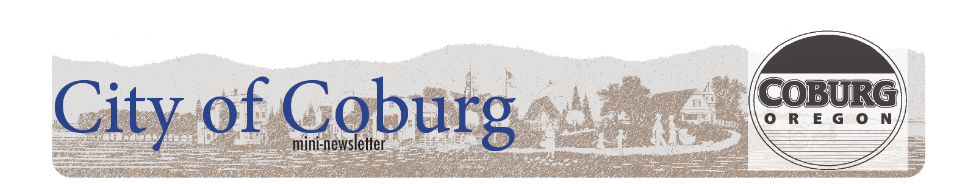
CAPITAL PROJECT UPDATE
At the City we often get questions regarding the capital infrastructure projects of the City. Communicating facts to the public is important to us and therefore, we are offering the following updates on Capital Projects.
Park Projects
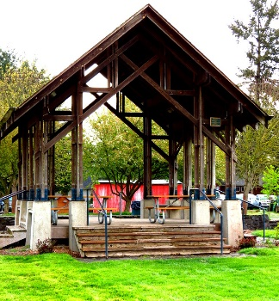
The City has completed a land swap to expand the ownership of Pavilion Park to the far south-end building owned by Ryan Thomas Construction. The community has enjoyed the use of this land for park activities for many years but did not legally own it, and therefore could not make improvements to it. With the expansion, the City has prepared a preliminary plaza design and submitted a grant request to develop a public plaza. The plaza will include increased accessibility to all abilities by including parking, pathways and restrooms. Additionally, the plaza plan seeks to enhance the citizen as well visitor experience in the park including more tables, benches, water feature, and landscaping elements. If the City is funded through this grant, the community will be given the opportunity to participate in providing comment on the final design of the plaza. The concept design was created by the citizen Park and Tree Committee with the help of the Public Art Committee.
The Coburg Loop path along Coburg Industrial Way is being expanded from where it ends just past Serenity Lane north toward the Trails End Park. This project is being funded by a regional funding grant as well as System Development Charges. The project is scheduled to take place in the summer/fall of 2022. However, due to current construction climate, it may be pushed out until 2023.
Street Projects
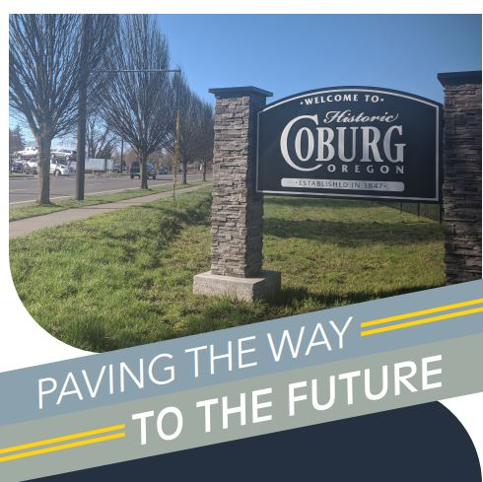
The City is entering into a street improvement plan that will take place over the next five years. Included in that plan is treatment for our best roads in the form of slurry or chip seals, as well as reconstruction and overlays of our worst roads. The staff are currently scheduling the projects based upon available funds and capacity of the City to get them done in a timely manner. The City is applying for a loan to fund some of the larger projects for which the recently adopted Transportation Utility Fee will help to pay the debt payments. The majority of street projects must take place during the dry season and therefore must be scheduled over several years. At this time the following projects are scheduled for this summer:
- Roberts Road Reconstruction
- Mckenzie Street on the east and west side of Willamette (increased pedestrian safety). Funded in part by the Small City Allotment Grant.
- Thomas Street Area – (Aligning with water infrastructure upgrades)
- Seal Treatments – Abbey, Water, Austin, Champ and Christian
The City’s collector system maintenance and reconstruction are scheduled for the summer of 2023. This project is funded through regional grants and includes portions of Coleman, Skinner, Delaney, Locust, and North Harrison. A collector system is a series of streets which carries traffic from minor streets (residential) to arterial highway or major streets (Pearl & Willamette).
Also in the works is an update to street standards in Coburg, and specifically narrow residential and collector streets. These standards will offer an alternative design to federal standards that might not be appropriate for some of Coburg’s historic streets. An example would be reducing the need to add sidewalks on a collector street when the street is too narrow to do so without disrupting the existing residential homes constructed close to the road.
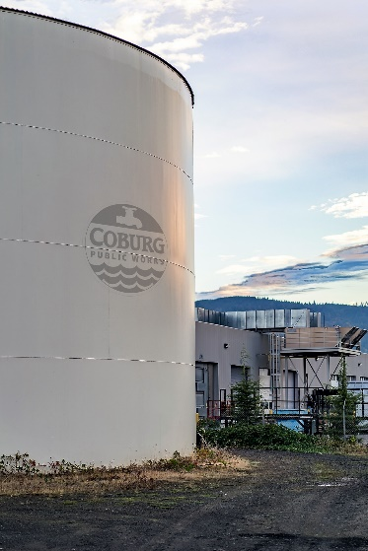
Water Projects
The City is in year two of a Water Master Plan Capital Project which includes water mainline replacement, construction of an additional public well, water to the east-side of the freeway through a bore under I-5, and construction of a reservoir. These projects will increase the resiliency of the public water source, serve City properties that are not being currently served, and reduces the amount of system repairs by replacing line that has served its useful life. This project is funded through Business Oregon. The work will take place over several years and is subject to change based on information provided through the engineering phase of each of the individual projects. City staff are also attempting to align water and street projects to the greatest extent possible to avoid unnecessary disruption to the neighborhoods.

Sewer Project
The City is currently in the engineering phase of planning for the replacement of Premier RV’s wastewater tanks which will likely take place in the summer of 2023.
At this time, all other Sewer Infrastructure is operating as expected and is built to serve the current anticipated growth of the community
Public Works Shop/SCADA Monitoring/Offices
The City is currently in the design stages of a Public Works Building which will serve as offices, house the SCADA monitoring/security system for Water and Wastewater, and include bays for the storage and maintenance of the public works fleet and equipment. The Public Works team currently utilizes a small control room for office space for six employees, and one small shop for all equipment, inventory, and maintenance for all of the Public Works Departments. This leaves the majority of the Public Works fleet and equipment to be stored outside.
Financing of Capital Infrastructure Projects
Financing of capital infrastructure projects comes from grants, loans, system development charges, as well as user fees. The City strives to find funding options to avoid the need to increase user fees. However, this is may not always be possible. The City Council and staff take the planning and funding of all projects very seriously by considering the impact to the taxpayers, while keeping the future life of the City infrastructure in mind.

